Canadian Agri-Food Automation
and Intelligence Network (CAAIN)

Technology Development
and
Smart Farm Networks Program

2026 Open Competition

PROJECT APPLICATION FORM (PAF)

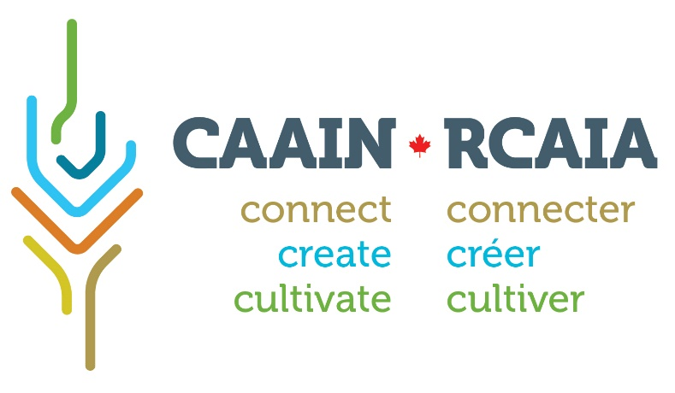

Project Application Form

The Project Application Form (PAF) is intended to facilitate development of applications to CAAIN’s funding programs. The PAF outlines the expectations of project teams and networks and provides context for CAAIN staff to assist applicants in developing a successful proposal. The PAF also allows CAAIN to ensure that proposed activities align with program goals.

Applicants must clearly align their proposals to CAAIN’s priorities for this funding competition. The proposal description should outline the problem to be addressed and the specific objectives and expected outcomes. Applicants should also review the eligibility criteria carefully to ensure that proposals and networks qualify for funding.

A separate PAF must be submitted for each potential proposal. Successful applicants will be invited to the next stage of the competition.

Please note that this is a competitive process. There is no assurance that applicants submitting a PAF will be invited to move onto the next stage or that applicants will be successful at any stage of the competition.

Detailed information about this competition can be found in the Program Guide, available on the CAAIN website: www.caain.ca.

Applicants will be notified by e-mail that their submission has been received.

Completed Project Application Forms must be submitted to info@caain.ca.

APPLICATION

APPLICATION INFORMATION

Lead Organization
Organization name: Click here to enter text

Lead Contact
Name : Click here to enter text Position : Click here to enter text
Email : Click here to enter text Telephone : Click here to enter text

Address : Click here to enter text
Number of employees : Click here to enter text
Business number : Click here to enter text

Team/Network Member
Project Member #2 : Click here to enter text
Contact Person : Click here to enter text
Address : Click here to enter text

Project Member #3 : Click here to enter text
Contact Person : Click here to enter text
Address : Click here to enter text

Project Member #4 : Click here to enter text
Contact Person : Click here to enter text
Address : Click here to enter text

(Add more lines as needed)

PROJECT INFORMATION

Relationship to Other Projects/Programs
Indicate whether your project/network activities is new, ongoing (continuation), or being resubmitted.
If yes, please include the relevant CAAIN project number.
Click here to enter text

Activity Details

2.2.1. Activity duration
Activity start dates must be the first day of the month. All project activities must be completed by March 31, 2028.

Proposed activity start date : Click here to enter text
Proposed activity end date : Click here to enter text
Estimated duration (months) : Click here to enter text

2.2.2. Target commodity
List all agricultural commodities that project/network activities are expected to involve.
Click here to enter text

2.2.3. Activity location (s)
List all locations where project/network activities are expected to take place, noting city/municipality and province.
Click here to enter text

2.2.4. CAAIN priorities
Identify the proposed activities that align with CAAIN’s priority areas for investment in Canada’s Agricultural sector (Select all that apply):
☐ Robotics and Automation
☐ Data-Driven Decision-Making
☐ Validation and/or Demonstration of Emerging Knowledge & Technology, including the development of Smart Farms or Smart Farm Networks.

Project Description

2.3.1. Project title (25-word maximum)
Provide a unique and descriptive title for the proposed activities. If the activity includes a smart farm network, include a brief description of the proposed network activities.
Click here to enter text

2.3.2. Keywords
Provide a list of up to 10 keywords or phrases that will help to identify the goals of your activities. These may relate to broad topic areas (e.g., livestock, crop, greenhouse, soil, and water quality), or to specific activities (e.g., hyperspectral imaging, optical recognition, real-time data-driven decision-making).
- Click here to enter text
- Click here to enter text
- Click here to enter text
- Click here to enter text
- Click here to enter text
- Click here to enter text
- Click here to enter text
- Click here to enter text
- Click here to enter text
- Click here to enter text

2.3.3. Project description (1-page maximum)
Describe the agricultural challenge or opportunity to be addressed and the approach(es) your team/network will use to develop a solution. Include the complementary expertise that the members will bring to the network to ensure its success, how the project activities will meet the objectives of CAAIN’s Investment in digital agriculture technologies as well as the novelty of this technology development.
Click here to enter text

2.3.4. Market landscape (half-page maximum)
Describe the market landscape that this project activities will address. Include the current solution and competitors, covering both digital and non digital options.
Click here to enter text

Project Outcomes

2.4.1. Technology Readiness Level (TRL)
Identify the Technology Readiness Level(s) of technologies targeted in this project. Indicate the TRL at the start and expected TRL at the end of the project. Itemize TRLs by project objectives or milestones as applicable. Please refer to the link below for a description of TRLs.
Technology Readiness Level (TRL) Assessment Tool (canada.ca)

TRL at the start of project : Click here to enter text
TRL at the end of project : Click here to enter text

2.4.2. Anticipated outcomes and deliverables (1-page maximum)
Explain what the outcomes of the activities are and how will it be demonstrated to end users and the path to widespread adoption of the solution(s).
Click here to enter text

Regulatory Approvals
Do your activities require any regulatory screening or approval?
Canadian Environmental Assessment Act ☐ Yes, received ☐ Yes, will apply ☐ No
Human Ethics Approval ☐ Yes, received ☐ Yes, will apply ☐ No
Animal Care Approval ☐ Yes, received ☐ Yes, will apply ☐ No
Transgenic Crop Permit ☐ Yes, received ☐ Yes, will apply ☐ No
Transport Canada ☐ Yes, received ☐ Yes, will apply ☐ No
(e.g., drone registration, pilot certificate)
Other: Click here to enter text ☐ Yes, received ☐ Yes, will apply ☐ No

Project Financials
(Please note that the maximum CAAIN funding available per project is $3M CAD)
Estimated Industry cash contribution (60%):
SME #1: Click here to enter text $Click here to enter text
SME #2: Click here to enter text $Click here to enter text
Other: Click here to enter text $Click here to enter text

Estimated CAAIN funding requested (40%) : $Click here to enter text
Total Estimated Project Cost : $Click here to enter text
All public and private funding received or applied for must be declared.
Is there any other public funding aligned to this project? ☐ Yes ☐ No
If YES, list the source(s) and amount(s):
Source: Click here to enter text Amount: $Click here to enter text Confirmed? ☐ Yes☐ No
Source: Click here to enter text Amount: $Click here to enter text Confirmed? ☐ Yes☐ No
Source: Click here to enter text Amount: $Click here to enter text Confirmed? ☐ Yes☐ No

CAAIN will match only unencumbered cash contributions to the project for eligible supported expenses. CAAIN will not match:
- Financial contributions from governmental sources (including post-secondary institutions)
- In-kind contributions (however, these are considered to be important indicators of team commitment and likelihood of success. Relevant contributions should be assessed at fair market value.)
- Future revenue associated with the outcomes of the project such as tax incentives associated with the project (e.g., Canadian SR&ED credits)
- The value of shares paid in lieu of cash contributions
- Revenue from sales of the project’s end-products
- Non-eligible contributions (see Appendix 4 of the Program Guide)
However, the presence of these revenue sources may be noted in the application, as the merits of these contributions will be taken into consideration during the evaluation process. Applicants must justify the amount of funding requested to CAAIN, whose reviewers may choose to approve the project but award less funding than requested.

DECLARATION

Linkages to Foreign Economies
All linkages between program funding recipients and Russia’s economy must be reported. These may include:
- Russian investment or ownership linkages with a recipient, i.e., where Russian nationals and/or business interests may in part or in whole own the recipient business or any of its affiliates.
- Russian involvement on boards of directors of recipients.
- Recipient business operations in Russia, including branch plants or subsidiaries that are established in Russia.
- Close relationships between recipients and Russian entities or companies, including joint ventures, R&D collaborative agreements, or licensing agreements.
- Arms-length business relationships between recipients and Russia, including sales or exports to Russia or imports of materials, goods, equipment, or services from Russia and filing of patents.

Declaration
☐ I affirm that to my knowledge everything on this form is true and accurate.
☐ I have read and agree to the network’s commitment to CAAIN regarding IP and Data sharing
☐ I agree to all requirements as outlined above.
☐ I verify all participating project team members agree to CAAIN’s financial due diligence
☐ I am authorized to sign on behalf of the Project Team Lead Organization.

QUESTIONNAIRE
Where do you first hear about the 2026 CAAIN Open Competition?
☐ CAAIN Website or Network
☐ CAAIN LinkedIn
☐ Others: Click here to enter text

SIGNATURE
Click here to enter text |  | Click here to enter text
Name of Project Lead/Primary Contact on behalf of project team/network |  | Date
Click here to enter text
Signature

